International Cybersecurity and Digital Forensics Academy (ICDFA)
CIP-B101: Basic Computer Skills for Digital Forensics
Lab 1B: PC System Fundamentals, Disk Sectors and Partition Analysis

Student Name | Fuseini Imoru Kantuogaa
Registration Number | C11/26/DFIT/17291
Course Code | CIP-B101
Lab Title | Lab 1B: PC System Fundamentals, Disk Sectors and Partition Analysis
Date | 25th June 2026
Instructor | Madam Sara James
Platform | Windows 11 Pro (DESKTOP-KSBSLAR) + Kali Linux VM

1. Introduction
The purpose of this lab is to develop a foundational understanding of PC system components and how they relate to digital forensic investigation. A junior digital forensic trainee must be able to identify hardware and software specifications, map where evidence can exist across system layers, understand how processes and thread’s function, calculate disk and partition sizes from raw sector data, inspect partition tables using safe read-only commands, explain the PC boot process, and identify the file systems used by storage volumes.
This lab was carried out on a Windows 11 Pro system (DESKTOP-KSBSLAR) using built-in tools such as System Information (msinfo32), system info, PowerShell (Get-Disk, Get-Partition, Get-Volume, Get-Process), Disk Management (diskmgmt.msc), and DiskPart. A Kali Linux VM was also used for Linux-side partition inspection using lsblk, fdisk, parted, blkid, and df. All commands were executed in read-only mode in accordance with the forensic mindset: observe, record, calculate, verify, and document without altering the evidence source.

2. Tools Used
Tool / Command | Platform | Purpose
msinfo32 (System Information) | Windows 11 | System specification and BIOS mode
systeminfo | Windows 11 CMD | Full system and network information
Get-Disk / Get-Partition / Get-Volume | Windows PowerShell | Disk and partition inspection
Get-Process | Windows PowerShell | Running process observation
DiskPart (list disk / list partition) | Windows CMD (Admin) | Partition table listing
Disk Management (diskmgmt.msc) | Windows 11 | Visual disk and partition layout
lsblk / fdisk / parted | Kali Linux VM | Linux partition inspection
blkid / df / lsblk -f | Kali Linux VM | File system identification
Python 3 / Calculator | Both | Manual partition size calculations

Part A – System Identification and Evidence Layer Mapping

A1. System Specification (msinfo32 – Screenshots 1 & 2)
The following screenshots were captured from msinfo32 showing the key system identifiers:
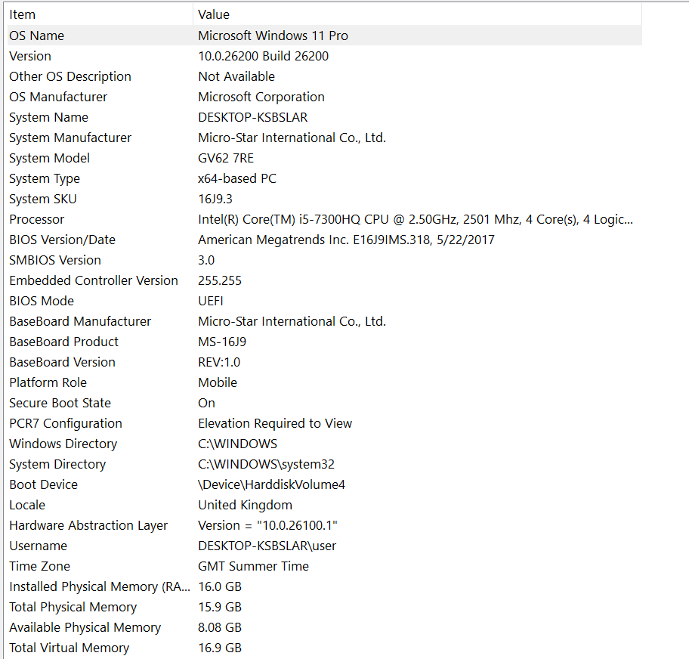
Screenshot 1: msinfo32 – OS Name, Version, System Type, Processor, BIOS Mode, Memory, Secure Boot
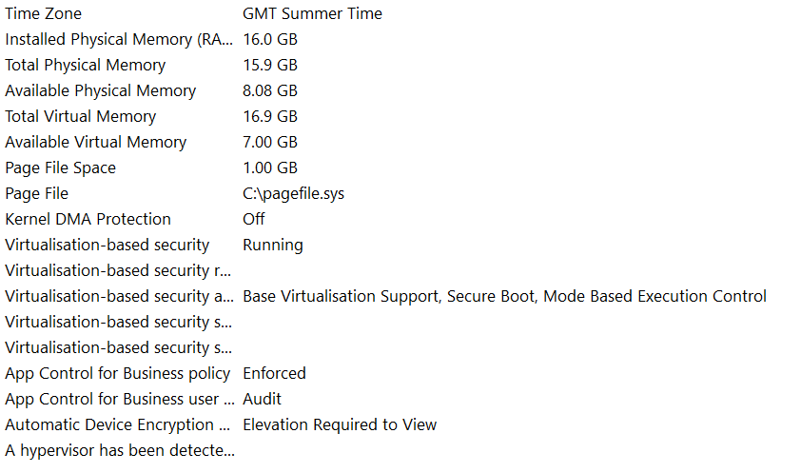
Screenshot 2: msinfo32 continued – Memory, Virtual Memory, Page File, Security features

Item | Value
OS Name | Microsoft Windows 11 Pro
OS Version | 10.0.26200 Build 26200
System Type | x64-based PC
Processor | Intel(R) Core(TM) i5-7300HQ CPU @ 2.50GHz, 2501 MHz, 4 Core(s)
System Model | MSI GV62 7RE
BIOS Mode | UEFI
Secure Boot State | On
Installed RAM | 16.0 GB
System Manufacturer | Micro-Star International Co., Ltd.

A1. systeminfo Command Output (Screenshots 3 & 4)
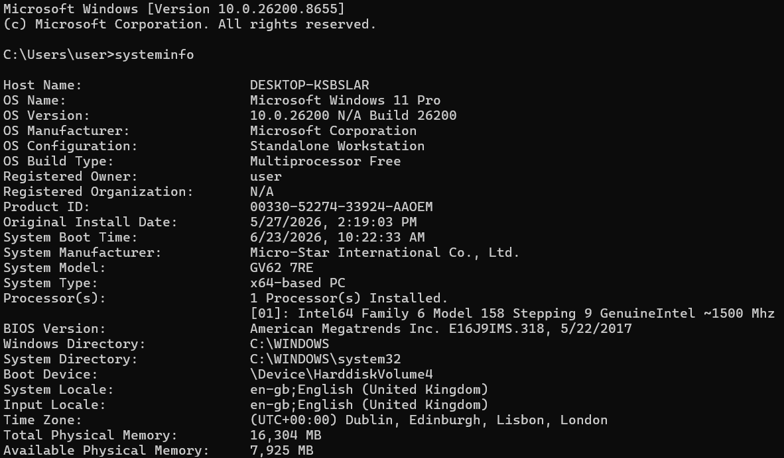
Screenshot 3: systeminfo – Host Name, OS details, Processor, Boot Device, Time Zone
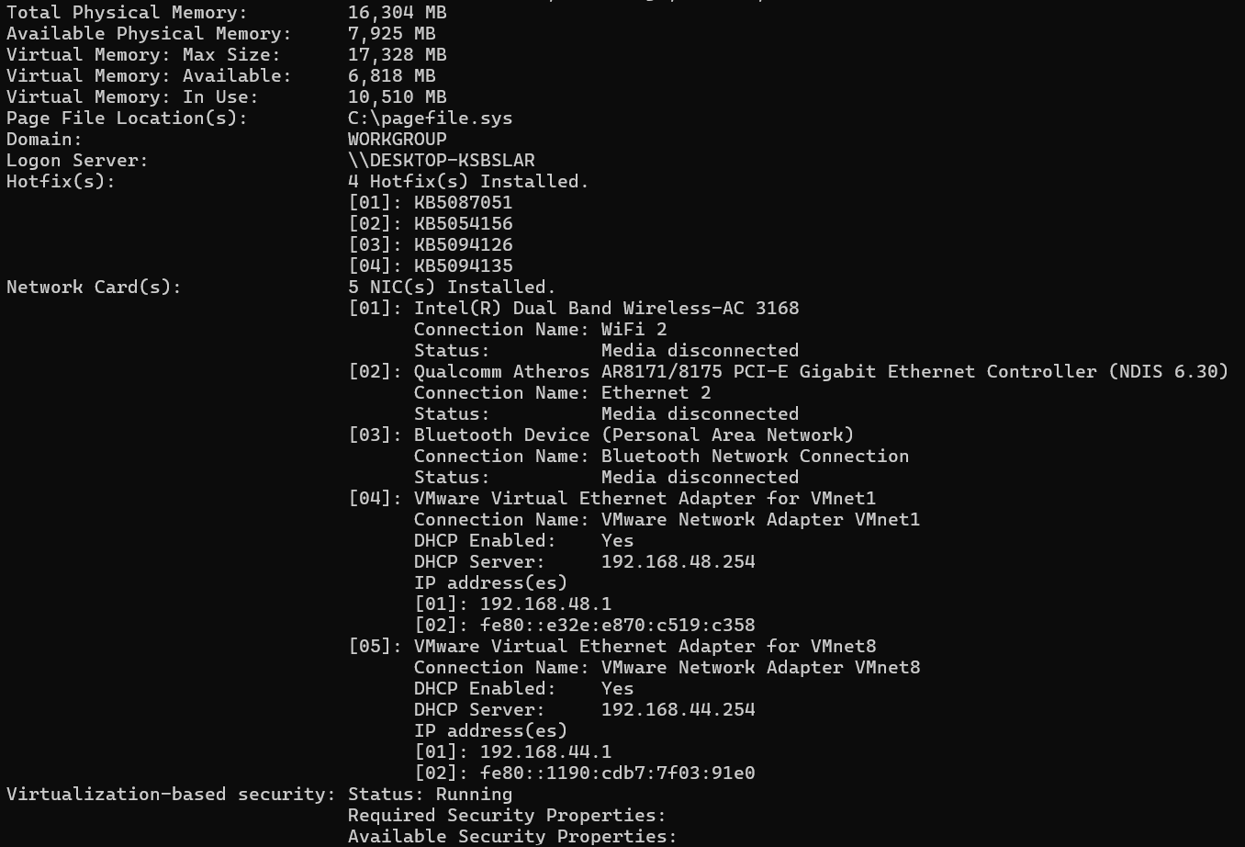
Screenshot 4: systeminfo continued – Memory, Hotfixes, Network Cards

A2. Storage Information – Get-Disk, Get-Partition, Get-Volume (Screenshots 5, 6, 7)
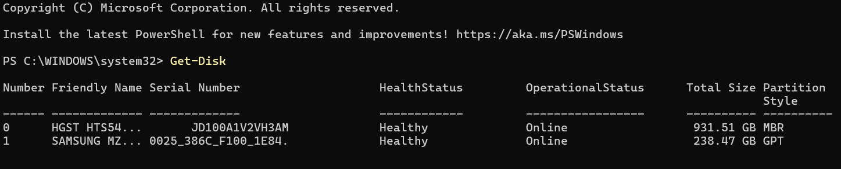
Screenshot 5: Get-Disk – Two disks detected: Disk 0 (HGST HTS54, 931.51 GB, MBR) and Disk 1 (Samsung MZ, 238.47 GB, GPT)

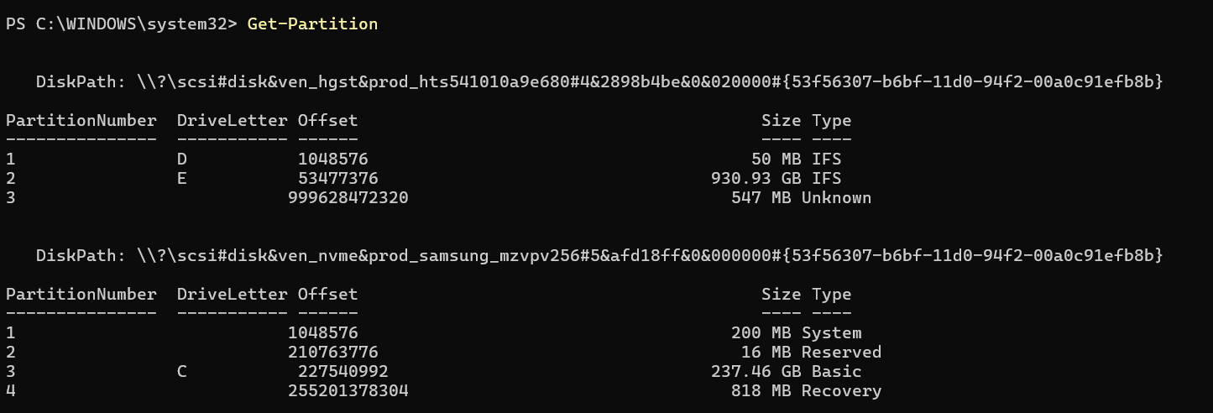
Screenshot 6: Get-Partition – Partition layout for both disks

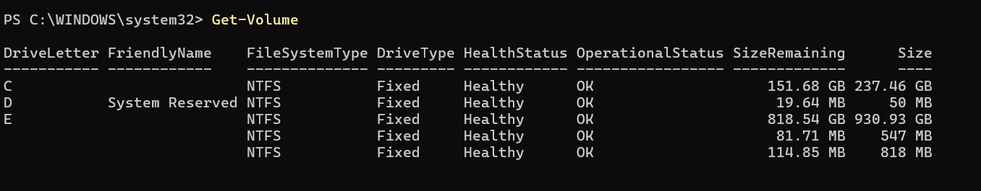
Screenshot 7: Get-Volume – All volumes with file system type and sizes

A3. Evidence Layer Mapping Table
Layer / Source | Example Evidence | Where It May Be Found | Why It Matters
User layer | Opened files, search terms, typed usernames | Recent files list, browser history, shell/PowerShell history | Links user actions directly to system activity and timeline
Application layer | Office document metadata, browser cache, chat logs | Application folders, SQLite databases, AppData directories | Shows what software created or processed the evidence
OS layer | Windows Event Logs, installed programs, user profiles, registry entries | C:\Windows\System32\winevt\Logs, HKLM registry hive, C:\Users | Records system events, logon sessions, and account activity
Disk / Storage layer | Deleted files, file fragments, MFT records, partition metadata | NTFS MFT, unallocated space, file slack, volume shadow copies | Supports file recovery, timeline construction, and artifact analysis
Memory / Process layer | Running malware PIDs, network connections, injected code | RAM capture, process list (tasklist / Get-Process), pagefile.sys | Reveals live system behavior that disappears after shutdown
Network layer | IP connections, DNS queries, network traffic | Windows Firewall logs, Wireshark captures, router logs | Identifies communication with external hosts during an incident

Evidence may exist in more than one layer because a single user action typically triggers multiple system components simultaneously. For example, opening a browser downloads files to the disk layer, creates a process in memory, generates a Windows Event Log entry at the OS layer, and leaves behind application cache at the application layer. A forensic examiner must inspect all layers to build a complete and accurate picture of events.

Part B – Program, Process and Thread Investigation

B1. Running Processes – Get-Process (Screenshot 8)
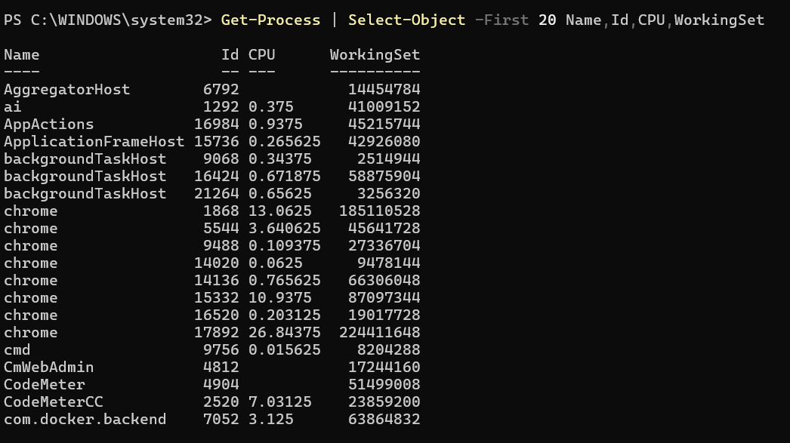
Screenshot 8: Get-Process | Select-Object -First 20 Name,Id,CPU,WorkingSet

Process Name | PID | CPU (s) | Likely Purpose
chrome | 1868 | 13.0625 | Google Chrome browser – user is actively browsing the web
cmd | 9756 | 0.015625 | Windows Command Prompt – used to run systeminfo and DiskPart commands in this lab
com.docker.backend | 7052 | 3.125 | Docker Desktop backend service – managing container virtualisation

B2. Program, Process, and Thread – Explanation
Program:
A program is a static set of instructions stored on disk. It exists as an executable file such as chrome.exe or cmd.exe. On its own it does nothing it only becomes active when launched by the operating system.
Process:
A process is a running instance of a program. When chrome.exe is launched, the OS creates a process and assigns it a unique Process ID (PID). The process has its own dedicated memory space, handles, and resources. Multiple instances of Chrome each appear as separate processes with different PIDs in the screenshot above.
Thread:
A thread is the smallest unit of execution within a process. A single process can contain many threads running concurrently. For example, one Chrome thread may handle rendering while another handles network requests. Threads within the same process share memory space but have their own execution state.
Forensic Relevance:
Process information is critical during malware analysis and live forensic triage. Suspicious processes with unusual parent-child relationships, unexpected names, high CPU usage, or connections to external IP addresses can indicate compromise. PIDs allow correlation between process activity and event logs. Inspecting running processes before shutdown can reveal malware that lives only in memory and disappears when the system is powered off. The Working Set column shows how much RAM each process is using, which can identify memory-resident threats.

Part C – Disk Sector and Disk Size Calculation

C1. Slide Reproduction Calculation
Values from the course slide: sectors per track = 400, heads = 12, cylinders = 17,000, bytes per sector = 512

Item | Formula / Value | Answer
Total sectors | 400 × 12 × 17,000 | 81,600,000 sectors
Total bytes | 81,600,000 × 512 | 41,779,200,000 bytes
Kilobytes | 41,779,200,000 ÷ 1024 | 40,800,000 KB
Megabytes | 40,800,000 ÷ 1024 | 39,843.75 MB
Gigabytes | 39,843.75 ÷ 1024 | 38.91 GB

C2. Partition Size Calculations from This System
Disk 0 (HGST HTS54, MBR, 931.51 GB) – Partition 1 and Partition 2 are used for the Part G final assignment. The sector size for all disks is 512 bytes (confirmed by fdisk in the Kali VM which shows the same physical sector standard).

Disk 0 – Partition 1 (System Reserved, Drive D, 50 MB):
Reported size: 50 MB (DiskPart) / 50 MB (Disk Management)
Offset: 1,048,576 bytes = 1 MB from the start of the disk
Step 1: Convert size to bytes: 50 MB × 1,024 × 1,024 = 52,428,800 bytes
Step 2: Calculate sector count: 52,428,800 ÷ 512 = 102,400 sectors
Step 3: Convert to GB: 52,428,800 ÷ 1,024 ÷ 1,024 ÷ 1,024 = 0.0488 GB ≈ 50 MB

Disk 0 – Partition 2 (Primary Data, Drive E, 930 GB):
Reported size: 930 GB (DiskPart) / 930.93 GB (Get-Partition)
Offset: 53,477,376 bytes = ≈51 MB from start
Step 1: Convert size to bytes (using 930 GB): 930 × 1,024 × 1,024 × 1,024 = 998,579,896,320 bytes
Step 2: Calculate sector count: 998,579,896,320 ÷ 512 = 1,950,351,360 sectors
Step 3: Verify GB: 998,579,896,320 ÷ 1,024³ = 930.00 GB

Kali Linux VM – /dev/sda1 (ext4, 80.1 GiB):
From fdisk: Start = 2,048, End = 167,968,749, Sectors = 167,966,702, Sector size = 512 bytes
Step 1: Total bytes = 167,966,702 × 512 = 85,998,951,424 bytes
Step 2: Convert to GB: 85,998,951,424 ÷ 1,024 ÷ 1,024 ÷ 1,024 = 80.09 GB
df -h reports 79 GB usable – the difference is due to ext4 reserving approximately 5% of the partition for root use and filesystem metadata (journal, inode tables, superblock).

Part D – Safe Partition Table Inspection

D1. Windows – Disk Management (Screenshot 9)
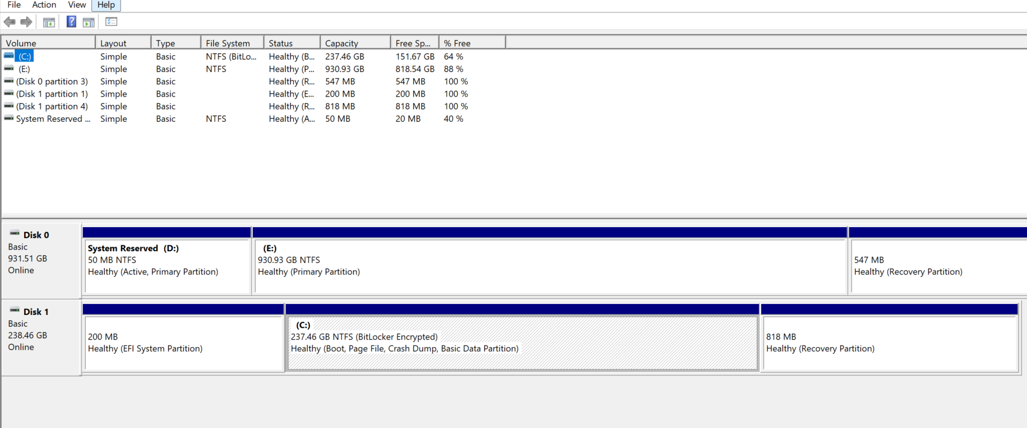
Screenshot 9: Disk Management showing Disk 0 (931.51 GB, MBR) with three partitions and Disk 1 (238.46 GB, GPT) with four partitions

Disk 0 (HGST, MBR) layout:
• Partition 1 (D:): System Reserved, 50 MB NTFS, Healthy (Active, Primary Partition)
• Partition 2 (E:): 930.93 GB NTFS, Healthy (Primary Partition)
• Partition 3: Recovery Partition, 547 MB, Healthy

Disk 1 (Samsung NVMe, GPT) layout:
• Partition 1: 200 MB, EFI System Partition
• Partition 2: 16 MB, Microsoft Reserved
• Partition 3 (C:): 237.46 GB NTFS, BitLocker Encrypted, Boot/Page File/Crash Dump
• Partition 4: 818 MB, Recovery Partition

D1. DiskPart – List Disk and List Partition (Screenshot 10)
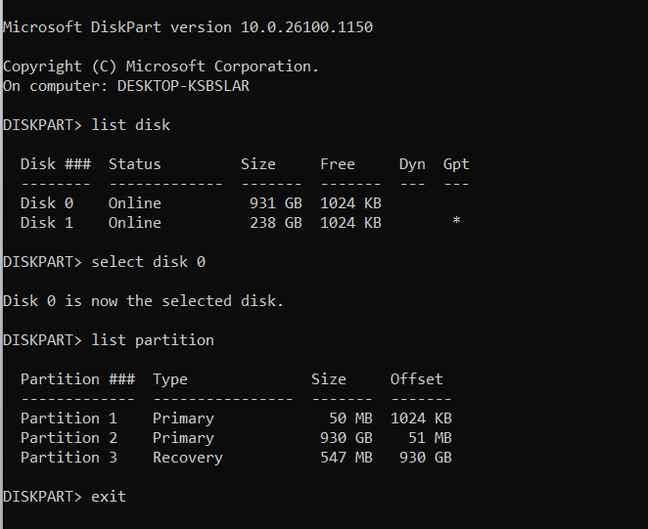
Screenshot 10: DiskPart showing two disks (Disk 0 = 931 GB MBR, Disk 1 = 238 GB GPT*) and Disk 0 partition table (Partitions 1, 2, 3)

DiskPart confirms Disk 1 has the GPT flag (*) and Disk 0 uses MBR (no * in Gpt column). Disk 0 contains three partitions: Partition 1 Primary (50 MB), Partition 2 Primary (930 GB), and Partition 3 Recovery (547 MB).

D2. Linux/Kali – lsblk, fdisk, parted (Screenshots 11 & 12)
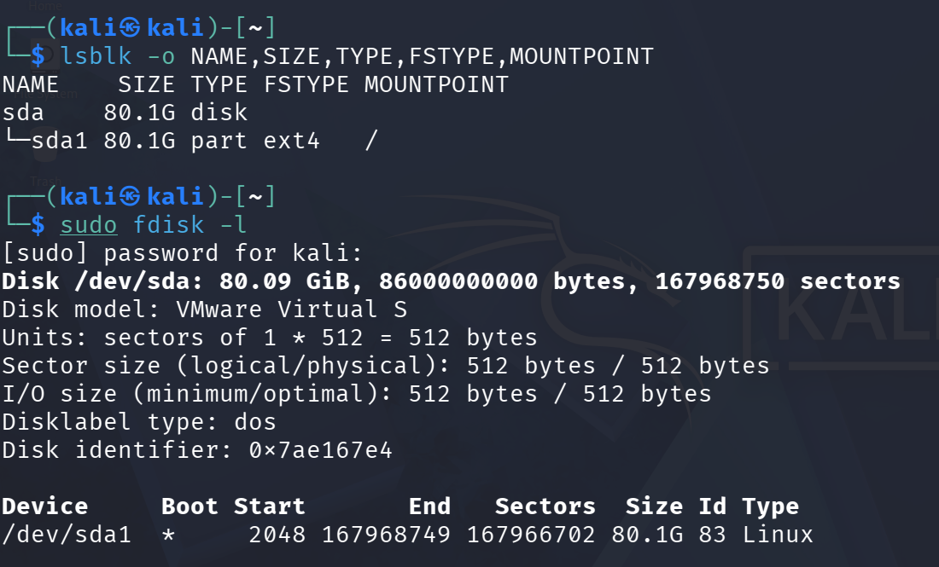
Screenshot 11: lsblk showing /dev/sda (80.1G disk) with sda1 (80.1G, ext4, mounted at /). fdisk -l confirms 167,968,750 sectors at 512 bytes, partition start=2048, end=167968749, sectors=167966702

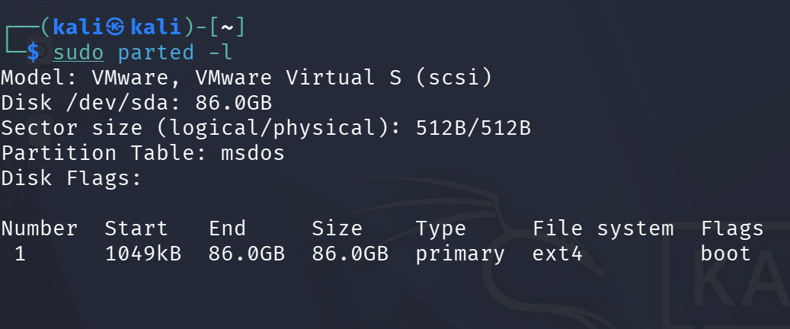
Screenshot 12: parted -l confirming Disk /dev/sda = 86.0 GB, sector size 512B/512B, partition table msdos, Partition 1 from 1049kB to 86.0GB (ext4, boot flag)

D2. Linux – blkid, df -h, lsblk -f (Screenshots 13 & 14)
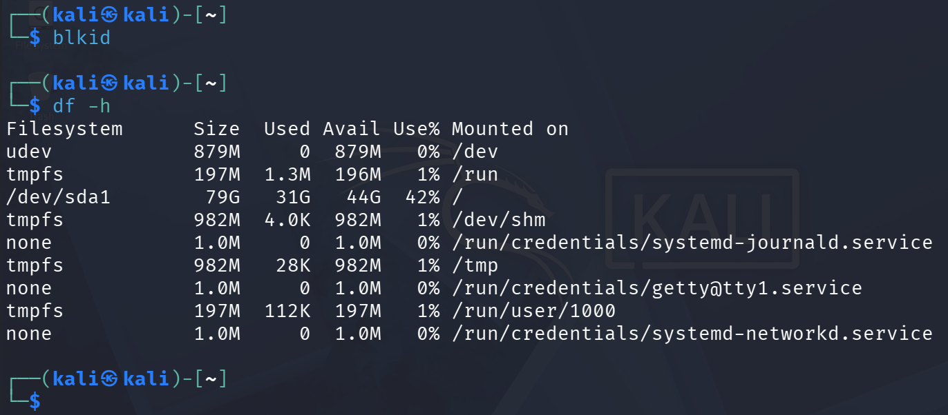
Screenshot 13: blkid (no UUID output visible; device not decorated) and df -h showing /dev/sda1 = 79G total, 31G used, 44G available (42% used), mounted at /

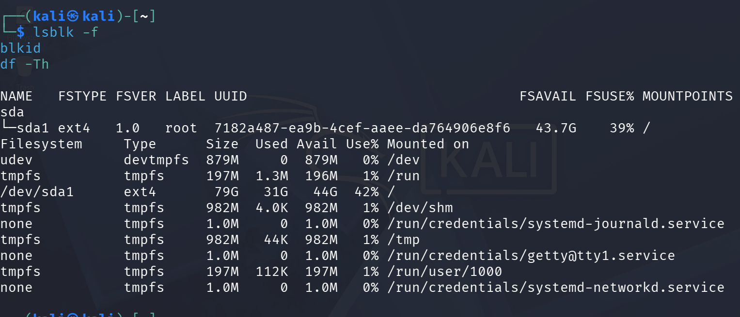
Screenshot 14: lsblk -f showing sda1 as ext4, version 1.0, label=root, UUID=7182a487-ea9b-4cef-aaee-da764906e8f6. df -Th confirms ext4 type, 79G size

Part E – MBR, GPT and Boot Process Explanation

E1. PC Boot Process – Numbered Sequence
The system under examination uses UEFI mode (confirmed by msinfo32 BIOS Mode = UEFI and the presence of an EFI System Partition on Disk 1).

# | Stage | What Happens | Forensic Relevance
1 | Power-on and POST | Hardware is powered and the CPU runs the Power-On Self Test. Memory, CPU, and storage devices are checked. | Hardware failure or physical tampering may prevent evidence access or corrupt data.
2 | UEFI Firmware Initialisation | UEFI firmware loads from the motherboard chip. Boot device order from CMOS/NVRAM settings is applied. | UEFI settings can reveal boot order manipulation or Secure Boot bypass attempts.
3 | Secure Boot Check | UEFI verifies the boot loader signature against the Secure Boot database. Unsigned code is rejected. | Secure Boot On (confirmed) means unauthorised bootloaders cannot run. Evidence of Secure Boot bypass is significant.
4 | EFI Boot Entry / GPT | UEFI reads the EFI System Partition (200 MB on Disk 1, Partition 1) and locates the EFI boot loader (e.g., bootmgfw.efi). | EFI partition contents can contain boot configuration artifacts and evidence of dual-boot or hidden OS configurations.
5 | Boot Loader / Boot Manager | Windows Boot Manager (bootmgr) loads and presents OS selection if multiple OS entries exist. Pre-kernel environment starts. | Boot configuration data (BCD store) can show installed operating systems and boot modifications.
6 | Kernel Loading | The Windows kernel (ntoskrnl.exe) and HAL load. Device drivers initialise. Services start. | Kernel crash dumps and driver load order can reveal rootkits or driver-level malware.
7 | OS Control and User Session | Windows Session Manager (smss.exe), WinLogon, and the user desktop load. The OS is fully operational. | Event logs, registry hives, and user activity begin to accumulate from this point.

This system uses UEFI boot mode. The boot device is \Device\HarddiskVolume4 (confirmed in systeminfo), which corresponds to the C: partition on Disk 1 (NVMe Samsung, GPT). Secure Boot is ON.

E2. MBR vs GPT Comparison
Feature | MBR | GPT
Age / Design | Older standard from the 1980s; used with BIOS/Legacy boot. | Modern standard used with UEFI systems.
Disk Size Limit | Commonly limited to approximately 2 TB. | Supports very large disks; theoretical limit approximately 9.4 ZB.
Partition Count | Maximum 4 primary partitions (or 3 primary + 1 extended). | Up to 128 partitions on Windows; no extended partition needed.
Partition Table Location | Stored in sector 0 (first 512 bytes), combined with boot code. | Primary GPT header at sector 1; backup GPT header at last sector.
Redundancy | No backup; damage to sector 0 can destroy partition information. | Backup GPT header aids recovery and cross-validation.
Forensic Issue | Critical evidence at sector 0; corruption can prevent partition interpretation. | Backup structures may assist recovery and GPT header validation.
This System | Disk 0 (HGST HDD, 931 GB) uses MBR. | Disk 1 (Samsung NVMe SSD, 238 GB, boot disk) uses GPT.

Part F – File System Identification and Interpretation

File Systems Identified on This System
Drive/Device | Volume Name | File System | Size | Observation
C: | (none) | NTFS (BitLocker) | 237.46 GB | Boot partition, encrypted with BitLocker. NTFS MFT and journals present.
D: | System Reserved | NTFS | 50 MB | Active primary partition on Disk 0. Contains boot files for legacy recovery.
E: | (none) | NTFS | 930.93 GB | Large primary data partition on Disk 0 (HGST HDD).
/dev/sda1 | root | ext4 | 80.1 GiB | Kali Linux VM root partition. UUID: 7182a487-ea9b-4cef-aaee-da764906e8f6.

Why File Systems Matter in Digital Forensics
File System | Common OS / Usage | Key Feature | Forensic Importance
NTFS | Modern Windows | MFT, journals, timestamps, permissions, alternate data streams | Rich metadata for timeline analysis; ADS can hide data; journal aids deleted file recovery.
FAT/FAT32 | Removable media, older systems | Simple directory table, no journaling | Easy to recover deleted files; widely used on USB drives recovered in investigations.
exFAT | Large USB/SD cards | Extended FAT for large files | Commonly found on camera memory cards; simpler metadata than NTFS.
ext4 | Linux systems (Kali, Ubuntu) | Inode-based, journaling, extents | Inode timestamps and journal support forensic timeline reconstruction on Linux systems.
HFS+ | Older macOS | Catalog B-tree, resource forks | Important in Mac investigations; metadata and timestamps differ from NTFS.

All Windows volumes on this system use NTFS. NTFS is forensically rich because it maintains a Master File Table (MFT) with entries for every file, including $STANDARD_INFORMATION and $FILE_NAME timestamps, file size, permissions, and alternate data streams. The NTFS journal ($LogFile and $UsnJrnl) records changes and can help recover deleted or modified file information. The BitLocker encryption on the C: drive means the contents are not readable without the decryption key a significant consideration in a forensic investigation.
The Kali Linux partition uses ext4, which is an inode-based journaling file system. Each file has an inode storing access, modification, and change timestamps, as well as permissions and ownership data. The journal (located in the /dev/sda1 partition) records metadata changes and can assist in recovering partially deleted data and understanding recent filesystem activity.

Part G – Final Practical Assignment: Partition Size Verification
The partition table used for this assignment is from Disk 0 (HGST HTS54, MBR, 931 GB) as inspected via DiskPart (Screenshot 10) and Get-Partition (Screenshot 6). Sector size = 512 bytes.

Task | Required Evidence | Answer
Identify Partition 1 | Screenshot of partition table and command output | Disk 0, Partition 1: Type = Primary, Drive Letter = D, Size = 50 MB (DiskPart Screenshot 10 / Get-Partition Screenshot 6)
Record Partition 1 sector count | Start sector, end sector or sector count | Get-Partition offset = 1,048,576 bytes. Size = 50 MB = 52,428,800 bytes. Sector count = 52,428,800 ÷ 512 = 102,400 sectors.
Calculate Partition 1 size | Formula and result in GB | 102,400 × 512 = 52,428,800 bytes ÷ 1,024 ÷ 1,024 ÷ 1,024 = 0.0488 GB ≈ 50 MB
Identify Partition 2 | Screenshot of partition table and command output | Disk 0, Partition 2: Type = Primary, Drive Letter = E, Size = 930 GB (DiskPart) / 930.93 GB (Get-Partition). Offset = 53,477,376 bytes.
Record Partition 2 sector count | Start sector, end sector or sector count | Size = 930 GB = 998,579,896,320 bytes. Sector count = 998,579,896,320 ÷ 512 = 1,950,351,360 sectors.
Calculate Partition 2 size | Formula and result in GB | 1,950,351,360 × 512 = 998,579,896,320 bytes ÷ 1,024 ÷ 1,024 ÷ 1,024 = 930.00 GB
Compare with OS-reported size | Disk Management, Get-Volume, lsblk, or df output | Get-Volume reports E: = 930.93 GB. Disk Management shows 930.93 GB. DiskPart shows 930 GB (rounded).
Explain difference if any | Short explanation of rounding, reserved space, or GiB/GB differences | DiskPart rounds to the nearest GB (930). Get-Partition and Disk Management report 930.93 GB because they use more precise byte counts. The small difference (~0.93 GB) is due to rounding at the GB boundary and partition alignment overhead. Windows reports sizes in decimal GB (1 GB = 1,000,000,000 bytes) in some contexts and binary GiB (1 GiB = 1,073,741,824 bytes) in others, which contributes to minor discrepancies.

Step-by-Step Calculation Summary
Partition 1 (D: System Reserved, 50 MB):
Size in MB: 50 MB
Step 1: 50 × 1,024 × 1,024 = 52,428,800 bytes
Step 2: 52,428,800 ÷ 512 = 102,400 sectors
Step 3: 52,428,800 ÷ 1,073,741,824 = 0.0488 GB (approximately 50 MB)
Confirmed by: Get-Partition (50 MB), Disk Management (50 MB), Get-Volume (50 MB, NTFS, Drive D:)

Partition 2 (E: Primary Data, 930 GB / 930.93 GB):
Size from DiskPart: 930 GB
Step 1: 930 × 1,024 × 1,024 × 1,024 = 998,579,896,320 bytes
Step 2: 998,579,896,320 ÷ 512 = 1,950,351,360 sectors
Step 3: 998,579,896,320 ÷ 1,073,741,824 = 930.00 GB
Confirmed by: Get-Volume (930.93 GB NTFS, Drive E:), Disk Management (930.93 GB NTFS, Primary Partition)
Note: The 0.93 GB difference between DiskPart (930 GB) and Get-Partition (930.93 GB) is due to DiskPart rounding to the nearest GB integer while Get-Partition reports the precise byte-level partition size.

Screenshot Checklist
No. | Screenshot Required | Included?
1 | System Information (msinfo32) output | Yes
2 | system info command output | Yes
3 | Get-Disk – disk drive model and size output | Yes
4 | Get-Volume – logical volume/file system output | Yes
5 | Get-Process – running process/PID output | Yes
6 | Disk Management visual layout | Yes
7 | DiskPart list disk / list partition output | Yes
8 | Linux lsblk, fdisk -l output (Partition 1 evidence) | Yes
9 | Linux parted -l output | Yes
10 | blkid, df -h, lsblk -f – file system identification | Yes

Conclusion
This lab successfully documented the PC system fundamentals of the DESKTOP-KSBSLAR machine running Windows 11 Pro and its companion Kali Linux virtual machine. The key findings and lessons are summarised below.
The system runs a 64-bit Intel Core i5-7300HQ processor with 16 GB of RAM. It uses UEFI firmware with Secure Boot enabled, which is confirmed both in msinfo32 (BIOS Mode = UEFI) and by the presence of a 200 MB EFI System Partition on Disk 1. The operating system boots from the GPT-partitioned Samsung NVMe SSD (Disk 1), while the larger HGST HDD (Disk 0, MBR) is used for secondary data storage.
The disk and partition calculations demonstrated that the formula “sectors × bytes per sector = total bytes” is reliable for estimating partition sizes. Minor discrepancies between DiskPart, Disk Management, and Get-Partition values arise from integer rounding and the difference between decimal GB and binary GiB unit systems an important distinction that must be understood in forensic reporting.
The process investigation showed that modern systems run many concurrent processes, including multiple Chrome instances, Docker services, and system services. Understanding PIDs and process relationships is critical during live forensic triage, particularly when investigating memory-resident malware.
All Windows volumes use NTFS, which provides rich metadata for forensic analysis including MFT entries, NTFS journals, timestamps, and alternate data streams. The BitLocker encryption on the C: drive highlights the importance of acquiring decryption keys before disk analysis. The Kali VM partition uses ext4, an inode-based journaling system that similarly supports forensic timeline reconstruction.
The most important lesson from this lab is that a forensic examiner must be able to independently verify storage device information from first principles using sector counts and the conversion formula not simply accept the sizes reported by the operating system. All observations in this lab were made using read-only commands in compliance with the forensic mindset.

